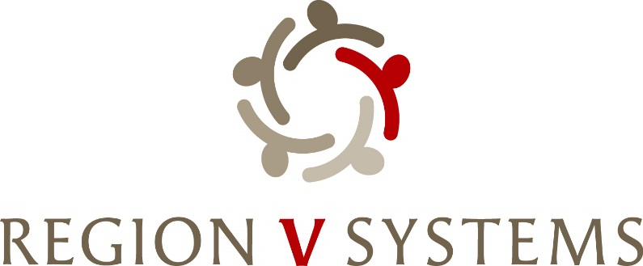

1645 N Street
Lincoln, Nebraska 68508
402-441-4343 • Fax: 402-441-4335

Opioid Steering Committee
May 21, 2024, 1:00-3:00
Center Pointe
2202 S 11th Street
Lincoln, NE 68502

- Welcome

- Obvious Expenditure- Flex Funds and Needs Assessment Proposal UPDATE

- Review of Grant Applications and Potential Awardees

- Review of timeline

- Update to Funding Matrix

- Next Meetings
  - June 11th,2024 from 1:00 to 3:00 at Region V Systems – 1645 N Street, Lincoln
  - July 9th, 2024 from 1:00 to 3:00 at Region V Systems

