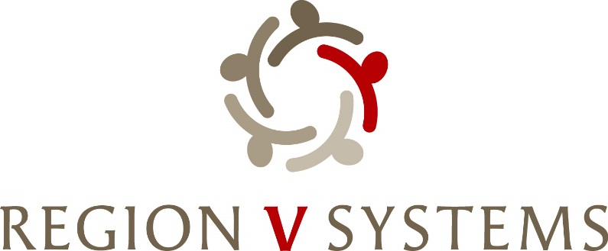

1645 N Street
Lincoln, Nebraska 68508
402-441-4343 • Fax: 402-441-4335

Opioid Steering Committee
April 9th, 2024, 1:00-3:00
Center Pointe
2202 S 11th Street
Lincoln, NE 68502

- Welcome

- Mindy Anderson- Knot – Obvious Expenditure- Needs Assessment Proposal

- Status of Request for Obvious Expenditure- Sandy Morrissey- Theresa Henning

- Obvious Expenditure- Flex Funds

- Review of timeline/ Discussion of Grant Release

- Review of Priorities from strategic planning during summit.

- Next Meeting
  - May 14th or 21st ? (Steering Committee will choose date based on timeline) – 1:00-3:00 p.m. Location TBD

- Next Steps-
Review of Grant Applications and Discussion of potential awardees

