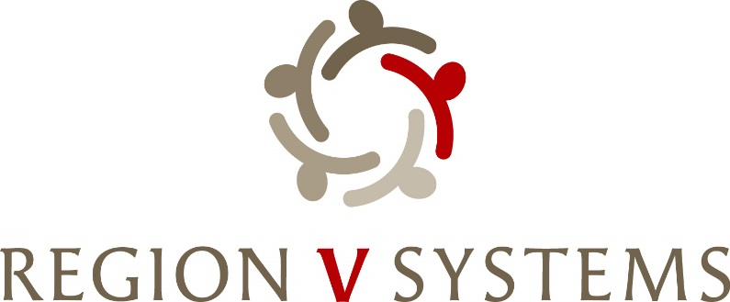
1645 N Street
Lincoln, Nebraska 68508
402-441-4343 • Fax: 402-441-4335

Opioid Steering Committee
January 9th, 2024, 1:00-3:00
Department of Health and Human Services
CFS- Conference Room P
301 Centennial Mall, Lincoln, NE 68508

- Welcome

- Introductions

- Sherrie Watkins- Opioid Response Network- Questions from Exhibit E

- Presentation of Data from Region 5- Davidson Wissing- DHHS- Division of Drug OD Prevention Coordinator

- Request for Obvious Expenditure- Amy Holman- Narcan

- Discussion/List of Obvious Expenditures- Vote if needed

- Region V Systems Opioid Settlement Funds Summitt- Resource Panel-????
  - March 19-20, 2024 – Wilderness Ridge Country Club (1800 Wilderness Woods Place, Lincoln, NE 68512)
  - Volunteers- Vic and Jeri- Mission Field Treatment Center

- Next Meeting
  - February 13th – 1:00-3:00 p.m. Location TBD

- Next Steps-
  - Introduction to Blueprint
  - Final List of Resource Panel
  - Summit Agenda and Registration

