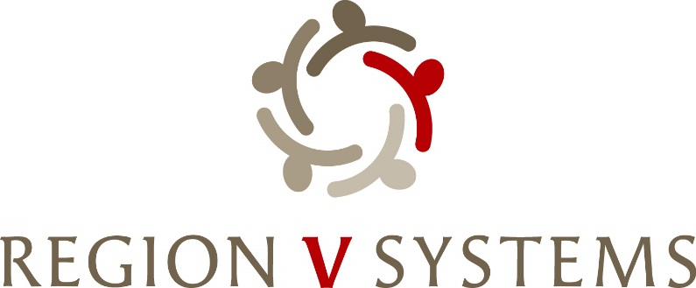

1645 N Street
Lincoln, Nebraska 68508
402-441-4343 • Fax: 402-441-4335

Opioid Steering Committee
March 12th, 2024, 1:00-3:00
Center Pointe
2202 S 11th Street
Lincoln, NE 68502

- Welcome

- Request for Obvious Expenditure- Sandy Morrissey- Theresa Henning

- Status of 2 YR Pilot Project Proposal

- Captain Ryan Dale- Presentation of current data

- Presentation of final Blueprint

- LOGO- 2 options

- Funding Matrix

- Region V Systems Opioid Settlement Funds Summitt- Update
  - March 19-20, 2024 – Wilderness Ridge Country Club (1800 Wilderness Woods Place, Lincoln, NE 68512)

- Next Meeting
  - April 9th– 1:00-3:00 p.m. Location TBD

- Next Steps-
Review of Priorities from Strategic Planning during Summit
Discussion of RFP/Grant Release

