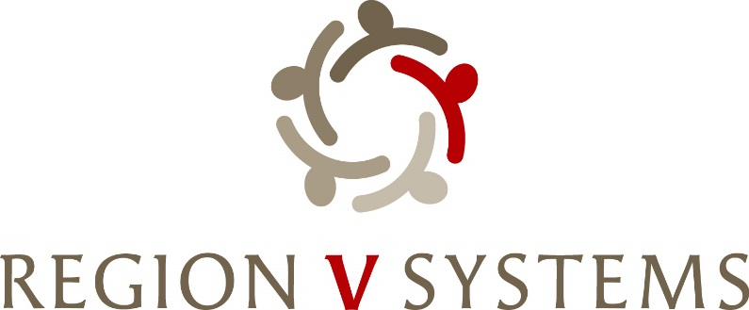

1645 N Street
Lincoln, Nebraska 68508
402-441-4343 • Fax: 402-441-4335

Opioid Steering Committee
February 13, 2024, 1:00-3:00
Department of Health and Human Services
CFS- Conference Room P
5220 S 16th Street, Lincoln Ne

- Welcome

- Review of Blueprint Draft

- Discussion of Opioid Funding

- Request for Obvious Expenditure- Amy Holman- Narcan and Harm Reduction Vending Machine

- Request for Obvious Expenditure- Sandy Morrissey- Med Safe Inlays, DeTerra, MYLNK

- Region V Systems Opioid Settlement Funds Summitt- Update
  - March 19-20, 2024 – Wilderness Ridge Country Club (1800 Wilderness Woods Place, Lincoln, NE 68512)

- Hybrid Discussion

- Next Meeting
  - March 12th – 1:00-3:00 p.m. Location TBD

- Next Steps-
Prepare for and Review Tasks for Summit
Review Funding Matrix

