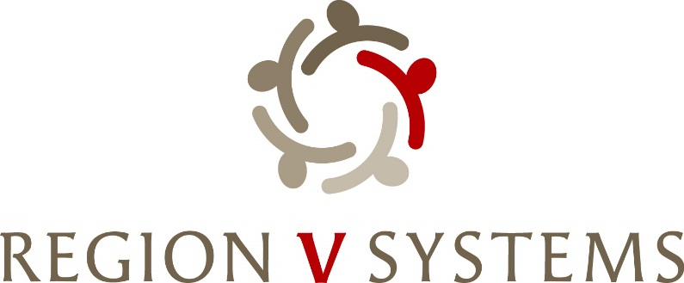
1645 N Street
Lincoln, Nebraska 68508
402-441-4343 • Fax: 402-441-4335

Opioid Steering Committee
December 12, 2023 – 1:00-3:00 PM
Integrated Behavioral Health Services
1430 South Street
Lincoln, NE 68502

- Welcome

- Introductions

- Review of Charter

- Review of Packet (Exhibit E, Timeline, Principles for the Use of Funds from the Opioid Litigation)

- Conflict of Interest- Will be emailed to everyone to sign before the January Meeting

- Region V Systems Opioid Settlement Funds Summitt
  - March 19-20, 2024 – Wilderness Ridge Country Club (1800 Wilderness Woods Place, Lincoln, NE 68512)

- Next Meeting
  - December 12, 2023 – 1:00-3:00 p.m. Integrated Behavioral Health Services (1430 South Street, Lincoln, NE 68502)

- Next Steps-
  - Review Exhibit E
  - Vote on Charter

