Region V Systems
Promoting Comprehensive Partnerships in Behavioral Health

Request for Proposal

Medically Monitored Inpatient
Withdrawal Management

September 15, 2021

Region V Systems
Request for Proposal
For Medically Monitored Inpatient Withdrawal Management

Release Date: Wednesday, September 15, 2021 Contact: Amanda Tyerman-Harper
Submittal Deadline: Friday, October 1, 2021 402-441-4354 No later than 4:00 p.m., To: atyerman@region5systems.net Region V Systems
1645 ‘N’ Street
Lincoln, NE 68508 Submission by fax, telephone, or e-mail is not permitted.

Region V Systems (RVS) is pleased to announce the release of a Request for Proposal (RFP) for entities interested in providing ASAM 3.7 Medically Monitored Inpatient Withdrawal Management services.

The “Request for Proposal” can be found at www.region5systems.net. The application must contain all required information. Applicants should submit the RFP in the following formats by Friday, October 1, no later than 4:00 p.m.:
- Electronically to Amanda Tyerman-Harper with RVS at atyerman@region5systems.net
- One (1) original and
- Five (5) copies of the proposal to Region V Systems

RVS reserves the right to request clarification or additional information from any Applicant. This solicitation does not obligate RVS to award a contract to any Applicant. RVS, at its option, reserves the right to waive as informality any irregularities in and/or reject any or all applications.

All questions regarding this RFP should be made in writing to Amanda Tyerman-Harper at
atyerman@region5systems.net. Questions to the identified contact person regarding this RFP may be made by e-mail using the “Request for Information” form available electronically at www.region5systems.net. Written responses to questions will be made by RVS personnel via email to the inquiring party within one (1) business day and emailed to all parties that submitted a Letter of Intent.

All notices, decisions, documents and other matters relating to the RFP process will be electronically posted on RVS’ website at www.region5systems.net. RVS reserves the right to amend, modify, supplement, or clarify this RFP at any time at its sole discretion.

Under the parameters of the RFP process coordinated by RVS, with the exception of clarifying questions, prospective Applicants are prohibited from contacting personnel of RVS, the Department of Health and Human Services, members of RVS’ Behavioral Health Advisory Committee (BHAC) or Regional Governing Board (RGB) regarding this solicitation during the period following the release of this RFP, during the proposal submission and evaluation period, and until a determination is made and announced. Violation of these provisions may be grounds for rejecting a reply to this RFP.

Note: No Applicant shall be excluded from participation in, denied the benefit of, subject to discrimination under, or denied employment in the administration of or in connection with this RFP because of race, color, creed, marital status, familial status, religion, sex, sexual orientation, national origin, Vietnam era or disabled veteran’s status, age, or disability. The Applicant shall comply with all applicable federal, state, and local nondiscrimination laws, regulations, and policies.

SECTION I – INTRODUCTION

Region V Systems
Region V Systems, a political subdivision of the state of Nebraska, has the statutory responsibility for organizing and supervising comprehensive behavioral health services in the Region V Systems area which includes 16 counties in southeast Nebraska. Region V’s geographical area includes Butler, Fillmore, Gage, Jefferson, Johnson, Lancaster, Nemaha, Otoe, Pawnee, Polk, Richardson, Saline, Saunders, Seward, Thayer, and York counties in southeast Nebraska.

Region V Systems, one of six regional behavioral health authorities in Nebraska, along with the state’s three Regional Centers, make up the state’s public behavioral health system, also known as the Nebraska Behavioral Health System (NBHS). Region V Systems is governed by a board of county commissioners, who are elected officials from each of the counties represented in the Regional geographic area. The Regional Governing Board (RGB) is under contract with the Nebraska Department of Health and Human Services System, the designated authority for administration of behavioral health programs for the state.

Each RGB appoints a regional administrator (RA) to be the chief executive officer responsible to the RGB. The RGB also appoints an advisory committee for the purpose of advising the Board regarding the provision of coordinated and comprehensive behavioral health services within the Region to best meet the needs of the general public. In Region V the Behavioral Health Advisory Committee (BHAC) is comprised of 15-20 members including consumers, concerned citizens, and representatives from other community systems in the Region.

Region V Systems’ purpose is to provide coordination, program planning, financial and contractual management, and evaluation of all mental health and substance services funded through a network of behavioral health providers. Currently, Region V Systems has 12 providers in its network who have met the minimum standards required to be a member of the network; each provider has a contract with Region V to deliver a variety of behavioral health services. Region V Systems, as payor of last resort, primarily serves financially eligible adults and youth with or at risk of serious mental illness, substance use disorder, and/or substance dependence.

SECTION II – STATEMENT OF PURPOSE

The purpose of this Request for Approval (RFA)/Request for Proposals (RFP) is to seek qualified providers for the development and provision of ASAM Level 3.7 Medically Monitored Inpatient Withdrawal services.

SECTION III – TARGETED GEOGRAPHICAL AREA / POPULATION

Geographical Area
Services shall be located in Lincoln, Nebraska but accessible & available to persons located in all 16 counties in Region V’s geographical area.

Population
The target population for which programs/services shall be provided is:
- Persons over 19 years of age
- Adults who reside within the aforementioned geographic area
- Persons in an intoxicated state who meet ASAM dimensional criteria for admission. The individual who is appropriately placed in a Level 3.7 WM detoxification program meets specifications in (a) and (b): (a) The individual is experiencing signs and symptoms of severe withdrawal, or there is evidence (based on history of substance intake, age, gender, previous withdrawal history, present symptoms, physical condition, and/or emotional, behavioral, or cognitive condition) that severe withdrawal is imminent. The severe withdrawal syndrome is safely manageable at this level of service AND (b) The individual is assessed as needing medication and monitoring at this level of service to complete detoxification and enter into continued treatment or self-help recovery because of inadequate home supervision or support structure, as evidenced by meeting [1] or [2] or [3]: [1] The individual requires medication and has a recent history of withdrawal management at a less intensive level of care, marked by past and current inability to complete withdrawal management and enter into continuing addiction treatment. The individual continues to have insufficient skills or supports to complete withdrawal management; or [2] The individual has a recent history of withdrawal management at less intensive levels of service that is marked by inability to complete withdrawal management or to enter into continuing addiction treatment, and the individual continues to have insufficient skills to complete withdrawal management; or [3] The individual has a comorbid physical, emotional, behavioral, or cognitive condition (such as chronic pain with active exacerbation or posttraumatic stress disorder with brief dissociative episodes) that is manageable in a Level 3.7WM setting but which increases the clinical severity of the withdrawal and complicates withdrawal management.

SECTION IV – ELIGIBILITY CRITERIA

The applicant:
- May be a state, county, or community-based public, private not-for-profit, private for-profit agency, or faith-based organization.
- Must be a legal entity already established and functioning with paid personnel and demonstrable experience in working with the identified target population.
- Currently a member in Region V System’s Provider Network or, for new applicant, demonstrate how it meets all the requirements outlined in the Minimum Standards for Enrollment in Region V System’s Behavioral Health Provider Network (see Section XII) to be included as a member of Region V System’s Provider Network.
- In operation and in good standing (based on a current independent audit) for at least 12 months.
- Have approval as a Medicaid provider for 3.7 Medically Monitored Inpatient Withdrawal Management or willingness/ability to obtain Medicaid provider status.
- Hold national accreditation as an Inpatient program (required to be a Medicaid provider) by a nationally recognized accreditation organization i.e. CARF, COA, TJC or have an accreditation development plan that outlines the agency’s timeline (maximum 2 years) of applying for national accreditation.
- Have an existing, licensed facility in Lancaster County with the capacity to provide services to residents of the 16 counties in Region V’s service area.
- Must be able to support any start-up expenses as no capacity development funds are available.
- Have the ability to initiate services within 90 days of award.

SECTION V - SCOPE OF SERVICE

In Region V, the selected provider(s) will be responsible for the provision of Medically Monitored Inpatient Withdrawal Management services to the target population as outlined in the service definition below. Applicants must demonstrate the ability to assume responsibility for the administration, management, and provision of these behavioral health services as required in the RFP:

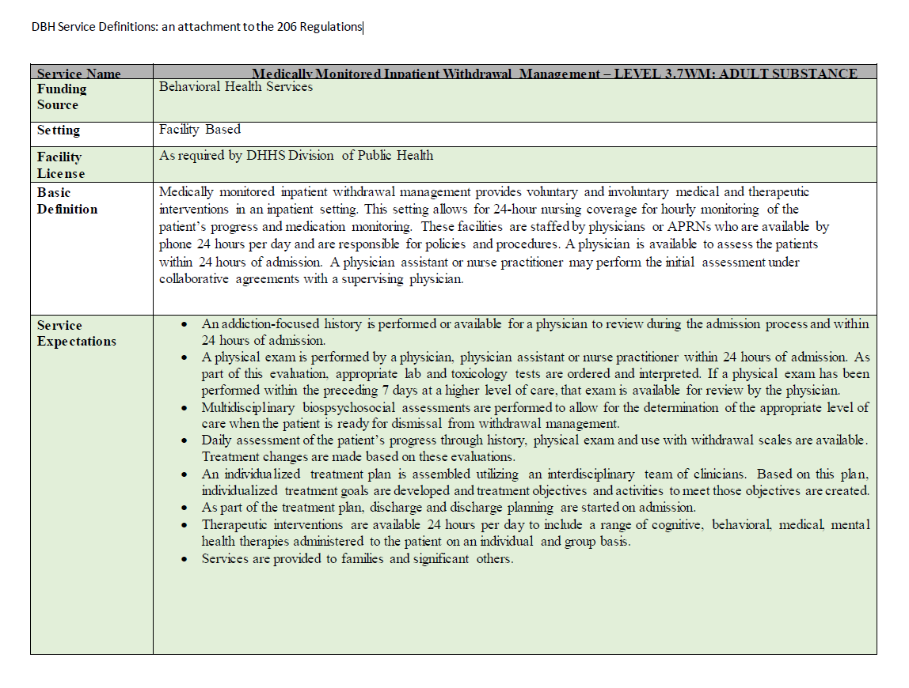
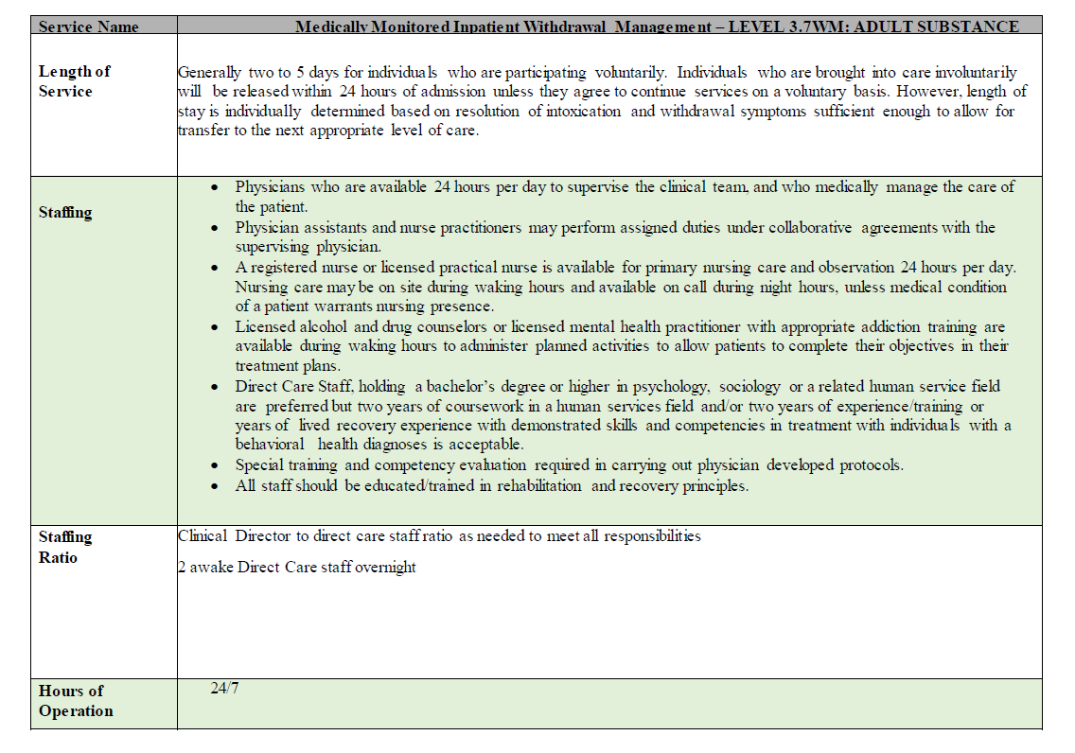

SECTION VI - FINANCIAL SPECIFICATIONS

Total Region V Systems’ Funds Available
The annual allocation available for a twelve-month period/Region fiscal year (July 1-June 30) is specified below:

Service Category | RVS Available Funds
Medically Monitored Inpatient Withdrawal Management | $227,000*
*If the contract is awarded to an existing Network Provider, existing contract funds will be used, and shifted as needed, before allocation of new funds to this service.

Funding Sources
Funding for this RFP is from the following sources:

STATE GENERAL FUNDING: The contract amount includes funds contracted to Region V Systems by the Nebraska Department of Health and Human Services, Division of Behavioral Health. Funds are passed through to the Regional Behavioral Health Authority and subsequently passed through from the Regional Behavioral Health Authority to the Network Provider(s).

FEDERAL BLOCK GRANT FUNDING: The contract amount includes funds that are contracted to the Nebraska Department of Health and Human Services, Division of Behavioral Health, by the Department of Health and Human Services, Substance Abuse and Mental Health Administration (SAMHSA). Funds are passed through to the Regional Behavioral Health Authority and subsequently passed through from the Regional Behavioral Health Authority to the Network Provider(s).

Reimbursement Methods
Services are reimbursed as follows:

FEE FOR SERVICE (FFS): Services are reimbursed at the Division of Behavioral Health statewide rate of $454.00 per day up to the designated amount specified in the contract.

Non-Transfer of Funding Award
Any contract awarded to a successful Applicant may not be transferred or assigned by the Applicant/contractor to any other organization or individual.

Use of Subcontractors
The successful Applicant may be permitted to subcontract for the performance of certain required administrative or programmatic functions. Anticipated use of subcontractors must be clearly explained in the RFP identifying the proposed subcontractors and their proposed role. Use of treatment subcontractors and the terms and conditions of the subcontract must be approved by RVS in advance of execution of any subcontract.

The successful Applicant is fully responsible for all work performed by subcontractors. No subcontract into which the successful Applicant enters with respect to performance under the contract will, in any way, relieve the successful Applicant of any responsibility for performance of its duties.

SECTION VI – RFP PROCESS

The RFP is designed to solicit proposals from qualified applicants who will be responsible for provision of Medically Monitored Inpatient Withdrawal Management services to clinically and financially eligible individuals in the Region V service area. Only those providers who submit a Letter of Intent are eligible to respond to this Request for Proposal (RFP).

All events related to the RFP process will follow the timeline outlined below:

Schedule of Events and Deadlines

Regional Governing Board September 13, 2021
(Motion to Approve RFP process)

Request for Proposal (RFP) Released September 15, 2021

Letters of Intent Due to Region V Systems September 22, 2021

Request for Proposal Application Deadline October 1, 2021

Review Committee Reviews Applications October 4, 2021

Behavioral Health Advisory Committee Meeting October 27, 2021
(Review Committee Recommendations)

Regional Governing Board November 8, 2021
(Motion to Approve Funding)

Award Announcement Disseminated and Contract November 8, 2021
Negotiations Begin

Letter of Intent
Region V Systems must receive a Letter of Intent (applicant must use Region V Systems’ “Letter of Intent” form, Appendix A) by 4:00 p.m., September 22, 2021, from applicants interested in completing a proposal. Applicants must submit a Letter of Intent to be eligible for funding; however, submitting a Letter of Intent does not bind the organization to submit an application. If there are changes or important interpretations to be communicated to prospective applicants prior to the proposal due date, those will be communicated to only those organizations which have submitted a Letter of Intent.

Contact Person
The contact person for all communication regarding this RFP is:

Amanda Tyerman-Harper
Region V Systems
1645 N Street
Lincoln, NE 68508
(402) 441-4343
atyerman@region5systems.net

Limits on Communications
Questions to the identified contact person regarding this RFP may be made by email using Appendix B, “Request for Information” form, available electronically at www.region5systems.net. Written responses to questions will be made by RVS personnel via email to the inquiring party and other providers who submitted a Letter of Intent within one business day.

With the exception of clarifying questions, Applicants are prohibited from contacting personnel of Region V Systems, the Department of Health and Human Services, Lancaster County, members of Region V’s Behavioral Health Advisory Committee (BHAC), or Regional Governing Board (RGB) regarding this RFP solicitation during the period following the release of this RFP, during the proposal evaluation period, and until a determination is made and announced. Violation of these provisions may be grounds for rejecting a reply to this RFP.

SECTION X – RFP SUBMISSION INSTRUCTIONS

All applicants must adhere to the following guidelines for submission of proposals:

1. The closing date for receipt of proposals is October 1, 2021. All proposals must be received in Region V Systems’ office by 4:00 p.m., October 1, 2021. The Applicant may choose and is responsible for the method of delivery to RVS except that facsimiles will not be accepted at any time; electronic transmission is required but does not replace the need to submit hard copies of the proposal.

Proposals must be sent or delivered in person to:

Region V Systems
1645 N Street, Suite A
Lincoln, NE 68508

- Information provided must be sufficient for review.
- Applicants shall not be allowed to alter or amend their proposals.
- FAX copies will not be accepted.
- Two-sided copying is NOT allowed.
- No requests for extensions of the due date will be approved.
- The RGB accepts no responsibility for mislabeled/mis-sent mail.
- Proposals received late will not be accepted and will be returned to the sender unopened.

- Replies not received by the Contact Person at the specified place and by the specified date and time will be rejected as non-responsive and returned unopened to the Applicant by RVS. Region V will retain one (1) original proposal for use in the event of a dispute.

- All proposals received by the date and time specified become the property of RVS. RVS shall have the right to use all ideas, or adaptation of ideas contained in any response to this RFP. Selection or rejection of the proposal shall not affect this right.

- Applicants must submit one (1) original and five (5) copies of each proposal. In addition, an electronic submission of the RFP should be made to atyerman@region5systems.net.

- Proposals must be typed in 12-point font or less, submitted on standard white 8 ½” by 11" paper, numbered consecutively on the bottom right-hand corner of each page, starting with the “Cover Page,” through the last document, including required appendices and attachments. (NOTE: The “Minimum Standards” section should be stapled and numbered separately. Only one copy of the “Minimum Standards” is required.)

- Use black ink.

- Staple or clip the original and each copy of the proposal at the upper left-hand corner. Do not use covers or add unsolicited attachments to your proposal.

- All information must be provided on the actual Region V Systems’ forms (the appendices provided in this RFP). All required forms are posted on the Region V website, www.region5systems.net.

- All instructions, conditions, and requirements included in this document are considered mandatory unless otherwise stated. RFP responses that do not conform to the items provided in this document will not be considered.

- Any costs incurred in the submission of proposals are the responsibility of the Applicant.

- The applicant may withdraw its proposal, with written notification, at any time in the process.

SECTION XI – PROPOSAL FORMAT

Proposals must be organized in the following sections in the following order:

- Cover Page: Complete the entire “Cover Page” (Appendix C) and obtain the signature of the chief executive officer, board chairperson, or other individual with the authority to commit the applicant to a contract for the proposed program/service.

- Executive Summary: Complete the entire “Executive Summary” (Appendix D). The “Executive Summary” should summarize the program narrative and budget justification narrative.

- Capacity Development Plan:
The purpose of the Capacity Development Plan is to clearly describe the program, development and implementation timeline, and budget needs. The Capacity Development Proposal must include:
- Program Narrative
- Development and Implementation Timeline Plan;
- BH-5 Goals and Objectives – one form is completed for each goal (Appendix E); and
- Budget and Narrative Budget Justification:
- BH20a-h for annual ongoing budget (Appendix F)
- Budget Narrative Justification that explains the ongoing annual expenses and why they are needed.

PROGRAM NARRATIVE
The Program Narrative is a written plan that describes, in detail, the Medically Monitored Inpatient Withdrawal Management program being proposed. The following information must be provided in as thorough and complete detail as possible:

- Name and address of the provider agency with an explanation of why the provider is capable of providing this program.

- Describe the purpose of the program. Explain the reason for developing the program in terms of the result expected to meet the needs of consumers.
- Describe the need for the program using current, valid data to justify why this program should be developed at the agency applying, in this geographic area, and for the purpose detailed above. Report the source and time period for the data. Include an explanation of why this need would logically lead to the development of the program being proposed.

- Describe the target population to be served and provide specific details about gender, ages, ethnicity, geographic location, mental illness(es) and/or substance dependence needs, medical needs, and other relevant information about the persons to be served in this program.

- Provide a general overview of how the program will be organized. Include information about how the provider's resources (facility space, personnel (current/new), equipment, other) and administrative structure are coordinated and directed to meet the needs of the consumers through the proposed program.

- List and explain the goals of the program which describe specific, measurable desired outcomes from a consumer's point of view. What will a consumer want to gain from this program? The goals should have a direct relation to the program purpose and should deal specifically with issues related to the services to be delivered in the program. The goals should address expected short- and long-term benefits for the target population. Program goals do not include organization management or program development goals. These goals are different than those identified on the BH-5.

- Thoroughly describe admission criteria and procedures for consumers to access the program or how the Behavioral Health clinical criteria will be used in this program.

- Describe the assessment process and procedures which will be used in the program. Include an explanation of what information will be gathered for each consumer and how consumers in this program will be screened for other problems (i.e., substance use problems, if developing a mental health program or mental illness, if developing a substance use program). If more detailed procedures need to be developed, include this in the Program Development/Implementation Schedule.

- List and include complete explanations of the specific services to be provided directly to the consumer:
- How individual recovery and wellness planning will be done with the consumer and what is included in this individual plan.
- What is involved in the service to be provided within this program.
- How the service will be coordinated with other programs.
- The provisions for periodic reassessment and individual plan revision.
- Discharge planning procedures, criteria, and follow-up.
- The projected average length of stay in the program for the consumer to successfully reach the desired results as specified in the goals (see G. above).
- How the program activities are designed for and appropriate to the developmental stage of the consumers to be served.

- Describe the procedures for direct consumer involvement in the program. Include an explanation of:
- How potential consumers will be informed about the program and consumer rights.
- How meaningful participation of consumers will be incorporated into the development, evaluation, and ongoing modification of the program.

- Discuss the capacity anticipated for the program. Program capacity means the total number of individual consumers considered "active" in the program at any given time. Daily census means the number of individual consumers who can be served on a single business day. Estimate the total number of consumers who can be served in a normal 12-month period.

- Discuss the program staffing proposed. Include an explanation of the qualifications, education/training and supervision of the positions which will provide any services (direct and indirect) in the program. Please attach a copy of any relevant job descriptions.

- Describe the quality assurance plan which will be used for this program and directed at desired outcomes for the consumer. Explain how information and data will be gathered to evaluate the program, what quality indicators will be used, how they will be used, who will be involved in making this happen, and timeframes for progress reports. Include the details of the quality improvement functions the agency plans to use in this program.

- Describe how the program is working to make progress toward co-occurring capability through assessment using the Compass-EZ, improvement plan, etc.

- Identify the specific facility needs of the program and explain how this program will meet those needs. Include an explanation of the relationship of this program within the operation of the provider agency.

DEVELOPMENT and IMPLEMENTATION TIMELINE PLAN
The Development/Implementation Timeline Plan will be developed on Form BH-5. The development plan includes an implementation schedule. The information will explain in detail the development process and show a clear step-by-step plan of how the program will be developed over a given period of time.
The Development/Implementation Timeline Plan may have several BH-5 forms that will identify the goals and objectives needed to develop and implement service capacity. Use a separate form for each goal.

Instructions for completing Form BH-5 (Appendix E)
Identify specific goals to address development issues (different from program goals for consumers as stated above).
Column A. Each goal should include time-limited, measurable objectives (including specific measurement indicators) which will all work together to successfully attain the goal.
Column B. Each objective will need to have specific activities that have to be accomplished in order to fulfill the objective.
Column C. Each activity must include the name of the staff person or the title of the position that will be primarily responsible for completing that activity.
Column D. Each activity must have a specific beginning and ending time identified. This time period must be within the proposed service development time period. Please be as specific as possible.
Column E. Each activity must identify the expected outcome that demonstrates that development activity has been accomplished. This will measure if the program is progressing toward full administrative, financial, and programmatic development through successful completion of each activity.
BUDGET/COST PROPOSAL
The cost proposal (budget) section should include the following two sections:
1. Itemized Annual Operating Budget. Explain and justify all items included in the annual operating budget including:
- Staffing needs by position, number of full-time equivalents (FTEs), and their respective salary and fringe costs separately.
- How ongoing operational, travel, capital outlay, personnel, professional fees, and consultant needs and costs were determined.
- Use Forms BH20c-h (Appendix F) to develop the detailed annualized ongoing budget for the service.
2. Budget Justification Narrative:
- This narrative will explain in detail why the costs listed on the budget itemization forms are necessary and how those costs were calculated.

SECTION XII – MINIMUM STANDARDS FOR ENROLLMENT IN REGION V SYSTEMS’ BEHAVIORAL HEALTH PROVIDER NETWORK

Any applicant, not a current member of Region V Systems’ Behavioral Health Provider Network, shall meet the requirements for the Minimum Standards for Enrollment in Region V Systems’ Behavioral Health Provider Network (See Appendix G - Minimum Standards for Enrollment in Region V Systems’ Behavioral Health Provider Network.)

The Enrollment Plan is a separate document which must be submitted at the same time as the proposal(s). One copy of the Enrollment Plan (“Enrollment Plan Checklist,” copies of actual documents, and the “Enrollment Plan Narrative[s]”) is required and shall be numbered consecutively in the bottom right-hand corner of each page, and stapled or clipped in the upper left-hand corner.

SECTION XIII – REVIEW AND EVALUATION PROCESS

Mandatory Requirements
Prior to the evaluation of the proposals by the Review Committee, a specific review of each proposal will be completed by Region V staff to determine if the submission includes the required components. If the requirements are not met, the proposal can be rejected and will not be forwarded to the Review Committee. Following are required items necessary for a proposal to be forwarded to the Review Committee:
- Letter of Intent
- Executive Summary
- Capacity Development Plan
- Budget/Cost Proposal.

Review Committee
All proposals that include all required components will then be evaluated by members of the Review Committee. This committee may include, but is not limited to, consumers, members of the community, representatives from the BHAC, the RGB, DBH and/or Region V Systems. The Review Committee will conduct a fair, impartial, and comprehensive evaluation of all proposals.

Recommendations from the Review Committee will be forwarded to the RGB for final determination and award. Working documents of the Review Committee, including applicants’ proposal scores, will not become public information nor will they be released to individual applicants. Proposals, however, are open to public inspection upon request.

Evaluation and Scoring
A contract award will be made based on the highest quality of service that meets the RGB’s requirements. The RGB shall consider the following in its evaluation of the proposal submitted:

- Cover Page (required, not scored).
- Executive Summary (required, not scored)
- Project Narrative (60 points)
- Development/Implementation Timeline (15 points)
- Budget/Cost Proposal (25 points)

Oral Interviews and/or Presentations
The Review Committee may conclude, after the completion of the evaluation process, that oral interviews and/or presentations are required in order to make final determinations. Applicants may be invited to appear before the RGB and/or Review Committee to respond to questions regarding their proposal(s).

Presentations
The presentation process will allow the applicant the opportunity to demonstrate, at a minimum, its understanding of the requirements of the proposal, its authority and reporting relationships within its organization, and its management style and philosophy.

Interviews
The RGB/Review Committee may request that the applicant participate in a structured interview to provide clarifying information.

NOTE: Only representatives of the RGB, Review Committee, as designated by the RGB, Region V Systems personnel, and the presenting contractor will be permitted to attend the oral interviews and/or presentations.

Once the oral interviews and/or presentations have been completed, the RGB reserves the right to make a final determination without any further discussion with the applicant regarding the proposal received. Any cost incidental to the oral interviews and/or presentations shall be borne entirely by the applicant and will not be compensated by the RGB.

Selection and Award
- The final decision regarding the award of the contract will be made by RVS’ Regional Governing Board and is subject to approval by DHHS. All decisions regarding funding allocations will be made on November 8, 2021, by the Regional Governing Board. Applicants will be notified by mail, on November 8, 2021, of the final funding decisions.

- The RGB retains the right to seek additional proposals, approve a portion of a proposal, not allocate funding for a particular service, or provide the service directly.

Region V Systems may deliver services only after:

- A competitive bidding process has been completed and a determination has been made that bids received do not adequately address the requirements of the RFP;
- A determination by the RGB that such services can be more reasonably and beneficially provided by RVS; and/or
- Approval by the DHHS, Division of Behavioral Health Services.

- The RGB reserves the right to void its intent to select and negotiate with an Applicant if the Applicant’s proposal is not approved by DHHS.

- Notification of contractor selection or non-selection will be made in writing by RVS.

- Issuance of this RFP in no way constitutes a commitment by RVS to award a contract, to pay costs incurred in the preparation of a response to this request, or to pay costs incurred in procuring or contracting for services, supplies, physical space, personnel or any other costs incurred by the Applicant.

- RVS reserves the right to reject any and all proposals or to make multiple awards.

- RVS reserves the right to withdraw the RFP at any time, including after an award is made and by doing so assumes no liability to any Applicant.

Appeal Process
An appeal of the RGB decision must be submitted in writing within 5 days of the award announcement to the identified contact person. The appeal will be reviewed within 3 business days and a response will be provided in writing within 5 business days

