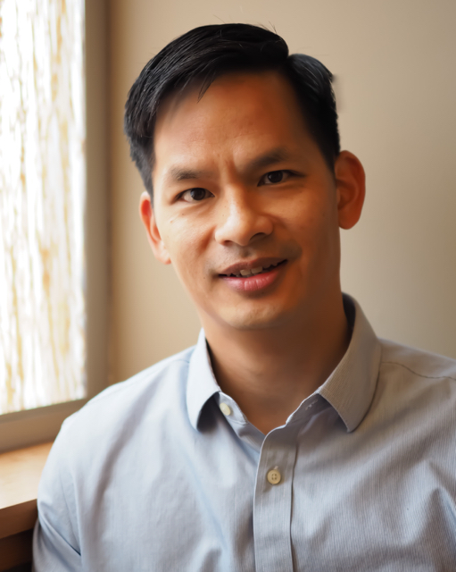 |  | Become A Certified  TF-CBT Provider  TF-CBT  Basic Training  February 27-28, 2020  TF-CBT  Basic Training  February 27-28, 2020
Registration Information:  When:  February 27-28, 2020  9am-5pm  Where:  Cornhusker Bank  8310 O St.  Lincoln, NE 68510  Park in the Kohl’s parking adjacent to the Cornhusker Bank. Conference will be held in the lower level community room.  Training Cost & Payment:  $300 per individual  To Register:  Contact Tammy Sassaman  402-441-7949  tsassaman@familyservicelincoln.org  Pay Via Check to:  Family Service  Cc Tammy Sassaman  501 S. 7th St  Lincoln Ne, 68508  **Register early as space is limited. |  | TF-CBT Basic Training  This presentation will provide an overview of TF-CBT and its use with traumatized children and adolescents. The interactive lecture will include information on identifying appropriate candidates for TF-CBT, a description of core components, and illustrations of its use through presentation and technical demonstrations.  Learning Objectives:  - Attendants will get a thorough overview of the entire Trauma-Focused Cognitive Behavioral Therapy model, an evidence-based treatment model for traumatized children and adolescents.  - Attendants will learn practical interventions from the model that they can apply in their work with clients.  Trauma Focused Components:  - Psychoeducation/Parenting Skills (Praise, Selective Attention)  - Relaxation (Progressive Muscle Relaxation, Abdominal Breathing)  - Affective Expression and Modulation (Feelings identification, Emotional Temperature-Taking)  - Cognitive Coping (Relationship between thoughts, feelings and behaviors)  - Trauma Narrative (Exposure though the medium of a story e.g. written or pectoral formats)  - Cognitive reprocessing of the Narrative (Cognitive errors e.g. black and white thinking, catastrophizing)  - Conjoint Parent-Child Sessions (Importance of  the involvement of a primary caregiver,  generalizing skills in the home, sharing the story  with the care giver)  - Safety Planning (assertiveness training, knowing boundaries)  Application of Trauma-Focused Cognitive Behavioral Therapy to  specific populations

Essential Information:

All participants must complete the on-line prerequisite course and bring their completion certificate the day of training.

https://tfcbt2.musc.edu/
- Cost of the prerequisite training is $35
- For certification attendees must participate in 12 monthly consultations following the training. Consultation costs are included in the training cost.
- 11CEU’s for the prerequisite training
- 14 CEU’s for the 2day training
- 12 CEU’s for Consultation calls

Park in the Kohl’s parking adjacent to the Cornhusker Bank. Conference will be held in the lower level community room.

Family Service will provide a light breakfast, lunch and a small afternoon snack.

Questions Contact Us:
Tammy Sassaman
402.441.7949
tsassaman@familyservicelincoln.org

Dr. David Hong

Dr. David Hong is a Licensed Clinical Psychologist. He earned his undergraduate degree in Psychology from Carleton College and his doctoral degree from the Minnesota School of Professional Psychology, where he studied Clinical Psychology with a minor in Child and Family Therapy. In over 20 years in community mental health settings, he has worked in several capacities including: outpatient therapy, psychological assessment, group therapy, day treatment, in-home therapy, residential treatment and clinical supervision. Dr. Hong is an adjunct faculty member at the Washburn Training Institute in Minneapolis, Minnesota. He is a nationally certified trainer of Trauma-Focused Cognitive Behavioral Therapy and provides training across the United States and internationally. He provided training and consultation to clinicians in 22 states and 5 countries. He currently does clinical work in a private practice, where he specializes in services for children, adolescents and immigrant populations, with a focus on trauma.

